|  |  |
| --- | --- |
| OMA reveals '24/7 vertical city' proposal for southbank by beulah ...  Opening a Mexican restaurant in Melbourne | Description  A just arrived Mexican chef came to Melbourne with one shot to open a successful restaurant in the city, but where is the ideal location?  Ernesto Cangas Compean  *Applied Data Science Capstone* |

**Introduction**

***Background***

The City of Melbourne is a local government area in Victoria, Australia, located in the central city area of Melbourne. Melbourne has 29 local government areas and the city of Melbourne is the one in the center of and which we are going to explore in this project. In 2018 the city had an area of 37 square kilometers and a population of 178,955 habitants.

Melbourne is an important financial center. With a highly diversified economy with particular strengths in finance, manufacturing, research, IT, education, logistics, transportation and tourism. In the 2018 Global Financial Centers Index, the city was ranked as having the 15th most competitive financial center in the world and is expected to rise five positions to be the 35th largest city economy in the world with a GDP of 273 billion USD at 2015-dollar prices.

The city has 14 suburbs with following habitants:

|  |  |
| --- | --- |
| Carlton | 18,535 |
| Carlton North | 6,300 |
| Docklands | 10,964 |
| East Melbourne | 4,964 |
| Flemington | 7,719 |
| Kensington | 10,812 |
| Melbourne | 47,285 |
| North Melbourne | 14,940 |
| Port Melbourne | 16,175 |
| Parkville | 7,409 |
| Southbank | 18,709 |
| South Wharf | 106 |
| South Yarra | 25,147 |
| West Melbourne | 5,515 |

***Problem***

The matter that I’m going to address is if there is an ideal location to open a Mexican restaurant in the city of Melbourne.

***Stakeholders***

The business request came from a just arrived immigrant chef coming from Mexico. He has one shot to launch his restaurant successfully, so having a proper location is crucial.

**Data**

***Sources***

The information providers of this projects consist mainly of tree sources:

1. City of Melbourne ABS 2016 census basic community profile

* <https://www.abs.gov.au/AUSSTATS/abs@.nsf/DetailsPage/3218.02018-19?OpenDocument>

1. Python geocoder to get the coordinates of Melbourne suburbs

* <https://towardsdatascience.com/geocode-with-python-161ec1e62b89>

1. Foursquare API

* <https://es.foursquare.com/developers/apps>

***Description***

Firstly, the population data will be distributed between zones, which in this case will be the city preestablished suburbs, in order to see the different number of residents and explore this data for our advantage.

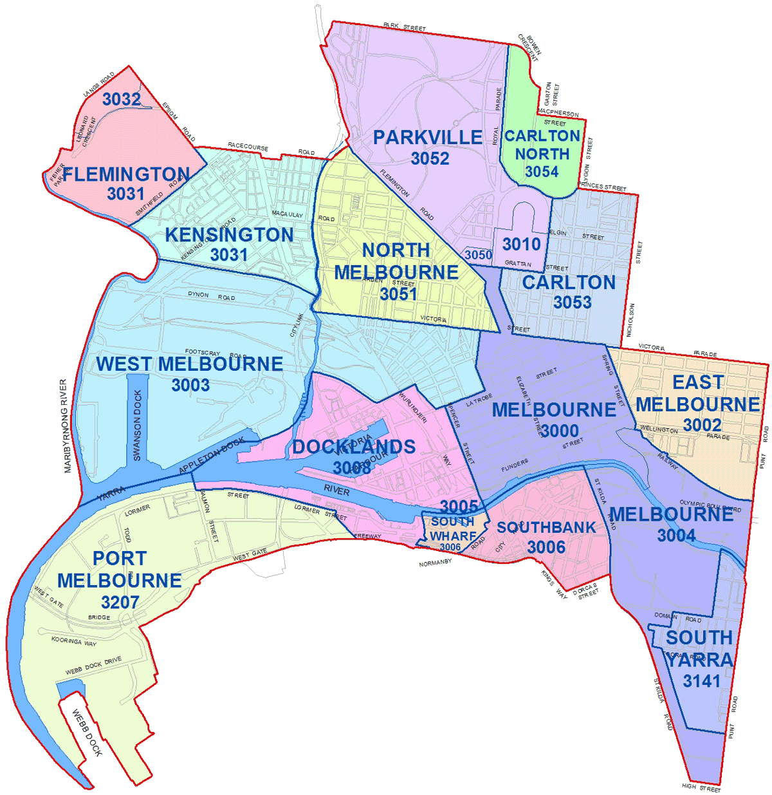

Secondly, the python geocoder will provide the coordinates of the neighborhoods to properly locate them in the city map with folium library.

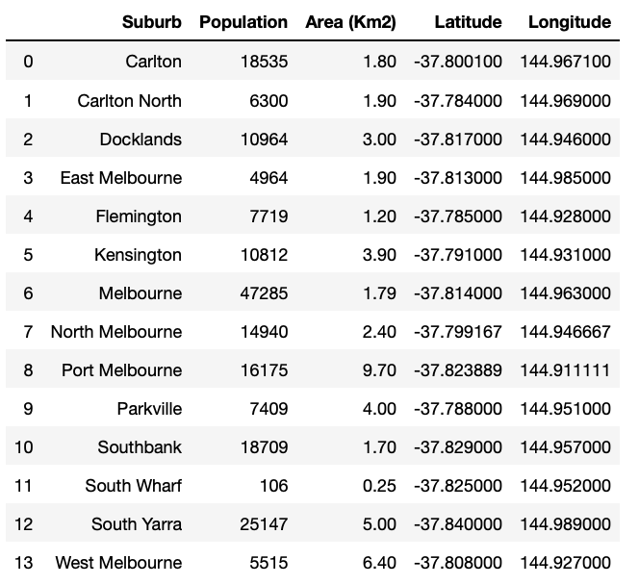

Lastly, Foursquare API venues explore and method to obtain the venues of given suburbs of Melbourne. Also, to get ranks and likes of restaurants by given venue id.

